**Topics: Descriptive Statistics and Probability**

1. Look at the data given below. Plot the data, find the outliers and find out $μ, σ, σ^{2}$

|  |  |
| --- | --- |
| **Name of company** | **Measure X** |
| Allied Signal | 24.23% |
| Bankers Trust | 25.53% |
| General Mills | 25.41% |
| ITT Industries | 24.14% |
| J.P.Morgan & Co. | 29.62% |
| Lehman Brothers | 28.25% |
| Marriott | 25.81% |
| MCI | 24.39% |
| Merrill Lynch | 40.26% |
| Microsoft | 32.95% |
| Morgan Stanley | 91.36% |
| Sun Microsystems | 25.99% |
| Travelers | 39.42% |
| US Airways | 26.71% |
| Warner-Lambert | 35.00% |

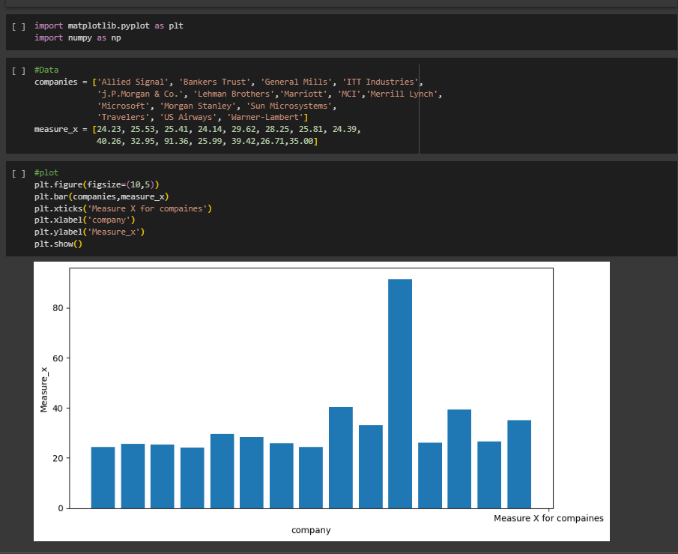

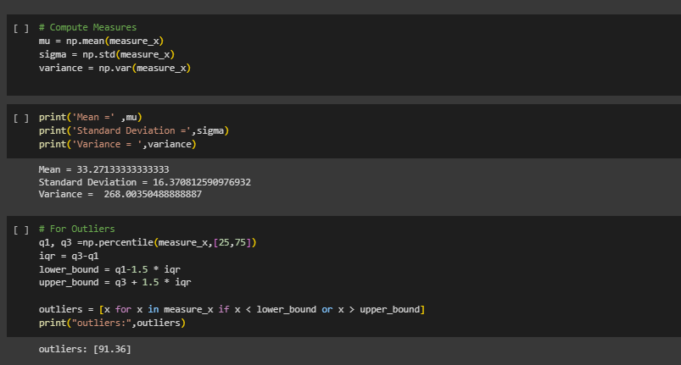



Answer the following three questions based on the box-plot above.

1. What is inter-quartile range of this dataset? (please approximate the numbers) In one line, explain what this value implies.

ANS:

Here clearly 25 is the outlier.

Median = 7

1st quartile = 5

2nd quartile = 12

IQR = (12-5) = 7

IQR tells us the range of the middle half of the data.

1. What can we say about the skewness of this dataset?

ANS: positively skewed

1. If it was found that the data point with the value 25 is actually 2.5, how would the new box-plot be affected?

ANS:

In that case there would have been no outliers, and it might

have affected in the values of mean and median slightly. The boxplot

might have moved towards right slightly.



Answer the following three questions based on the histogram above.

1. Where would the mode of this dataset lie?

ANS: Between 5-8(most frequent data)

1. Comment on the skewness of the dataset.

ANS: It is positively skewed.

1. Suppose that the above histogram and the box-plot in question 2 are plotted for the same dataset. Explain how these graphs complement each other in providing information about any dataset.

ANS: By comparing both o them it is very clear that the data would

be positively skewed. Also, would help us finding mean, mode value.

1. AT&T was running commercials in 1990 aimed at luring back customers who had switched to one of the other long-distance phone service providers. One such commercial shows a businessman trying to reach Phoenix and mistakenly getting Fiji, where a half-naked native on a beach responds incomprehensibly in Polynesian. When asked about this advertisement, AT&T admitted that the portrayed incident did not actually take place but added that this was an enactment of something that “could happen.” Suppose that one in 200 long-distance telephone calls is misdirected. What is the probability that at least one in five attempted telephone calls reaches the wrong number? (Assume independence of attempts.)

ANS: Probability of call getting misdirected is =(1/200)

Hence probability of call not getting misdirected = 1-(1/200) =

199/200

Number of phone calls attempted = 5

Therefore, probability that at least one in 5 attempted call reaches

the wrong number is:=1-(199/200) ^5= 0.025

1. Returns on a certain business venture, to the nearest $1,000, are known to follow the following probability distribution.

|  |  |
| --- | --- |
| x | P(x) |
| -2,000 | 0.1 |
| -1,000 | 0.1 |
| 0 | 0.2 |
| 1000 | 0.2 |
| 2000 | 0.3 |
| 3000 | 0.1 |

1. What is the most likely monetary outcome of the business venture?

ANS: Here the highest probability is for 2000.

1. Is the venture likely to be successful? Explain

ANS: Yes, because the total earnings of the venture is positive in value

i.e., 800 and highest probability of earning is 2000.

1. What is the long-term average earning of business ventures of this kind? Explain
2. What is the good measure of the risk involved in a venture of this kind? Compute this measure.

(iii)Ans:

The long-term average earning of business ventures of this kind can be calculated as:

The expected value of the return on investment.

The expected value is the sum of the products of each outcome and its probability:

E(X) = (-2000)(0.1) + (-1000)(0.1) + (0)(0.2) + (1000)(0.2) + (2000)(0.3) + (3000)(0.1)

= $800

Therefore, the long-term average earning of business ventures of this kind is $800.

(iv)Ans:

A good measure of the risk involved in a venture of this kind is the standard deviation of the return on investment.

The standard deviation is a measure of the spread of the distribution and indicates how much the outcomes deviate from the expected value.

The formula for the standard deviation is:

σ = sqrt[ Σ (Xi - E(X))^2 * P(Xi) ]

To calculate the standard deviation of the return on investment:

σ = sqrt[ (-2000 - 800)^2 * 0.1 + (-1000 - 800)^2 * 0.1 + (0 - 800)^2 * 0.2 + (1000 - 800)^2 * 0.2 + (2000 - 800)^2 * 0.3 + (3000 - 800)^2 * 0.1 ]

≈ $1564

Therefore, the standard deviation of the return on investment is approximately $1564, which indicates that there is a significant amount of risk involved in a venture of this kind.